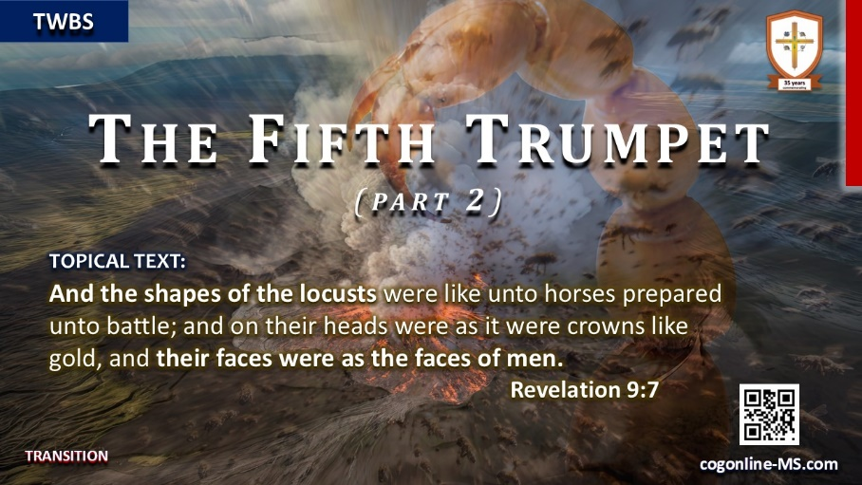

STUDY TEXT:
Revelation 9:7-12; Isaiah 13:11 (KJV)
^{Revelation 9:7} And the shapes of the locusts were like unto horses prepared unto battle; and on their heads were as it were crowns like gold, and their faces were as the faces of men.
⁸ And they had hair as the hair of women, and their teeth were as the teeth of lions.
⁹ And they had breastplates, as it were breastplates of iron; and the sound of their wings was as the sound of chariots of many horses running to battle.
¹⁰ And they had tails like unto scorpions, and there were stings in their tails: and their power was to hurt men five months.
¹¹ And they had a king over them, which is the angel of the bottomless pit, whose name in the Hebrew tongue is Abaddon, but in the Greek tongue hath his name Apollyon.
¹² One woe is past; and, behold, there come two woes more hereafter.
^{Isaiah 13:11And} I will punish the world for their evil, and the wicked for their iniquity; and I will cause the arrogancy of the proud to cease, and will lay low the haughtiness of the terrible.”
APPLICATION POINT:
throughout the inspired record of Revelation it is plainly set forth that this will be a unique period where Almighty Mighty God utilizes the entire sphere of His created realm to both punish and destroy the reign of the ascended Antichrist (who will temporarily reign over the world), and to equally punish those who pledged their soul alliance to his horrendously evil cause.

The Seventh Trumpet
(the 3rd Woe)
FOCUS TEXT: And the seventh angel sounded; and there were great voices in heaven, saying, The kingdoms of this world are become the kingdoms of our Lord, and of his Christ; and he shall reign for ever and ever. Revelation 11:15 (KJV)
Here in the key text of Revelations 11:15 found almost midway through the record of this final prophetic volume of Holy Writ, we should note that this pending event will marks the initiation of the final series of heavenly appointed transactions that will result in the absolute transfer of power and control of earthy (and eternal) matters of governance from the temporal proxy authorities of earthbound agents to the Supreme Person of the Son of God, the ”King of Kings and Lord of Lords.” (Rev. 19:16)
As has been recorded in the eternal record of Holy Scripture, it is wholly true that the spectacular unfolding, prelude-crescendo of epic apocalyptic events will have preceded this climatic moment.
In fact, in the opening inspired address of this final prophetic volume of divine truth we are rightly directed and commanded to consider and understand that the entire flow of human history (i.e., even the events of this present contemporary era) will have intentionally brought us to this explicit momentous occasion.
In the keynote text of Ephesians 1:10 we are particularly reminded: “That in the dispensation of the fulness of times he might gather together in one all things in Christ, both which are in heaven, and which are on earth; even in him.”
And thus, our (Christ followers) hearts should be leap with overwhelming joy and praises to the Lord God upon reading the wondrous declaration that has been purposely issued to us to serve as a present soul-anchoring word of enabling assurance.
Scripture rightly affirms that we should be living in anticipation that on the appointed day, this amazing holy decree will be made by the angelic servant sounding “the Seventh Trumpet.”
An Honest Contemporary Perspective
Only honest hearts will resign to confessing that we intensely struggle in our initial attempts to find the applicable relevance of these obviously pending prophetic matters, as they pertain to the unfolding of life events in our present sphere.
And perhaps the key reason behind our encumbrances is the fact that we have not learned to see beyond the wide borders of present life matters that incessantly intrude into the circle of our lives purposely seeking to completely fill the span of our field of vision.
It is true that the Lord Jesus has (and continues to) earnestly forewarn us in Luke 21:34a: “And take heed to yourselves, lest at any time your hearts be overcharged…”
Yet, despite the serious injunction of the issued divine prohibition, we must concede that we are yet overly prone to do precisely just that.
Therefore, we dare not attempt to casually gaze upon clearly more intricately involved matters and try to discern and decipher them apart from engaging in solemn prayer, and earnestly petition our living Lord to “open” our understanding and provide us with the essential guidance necessary to be able to navigate this premier path of keynote bible truths that plainly define the forward path of every member of His regenerated and redeem mystical body (the Church).
Perhaps, like the appointed Apostle John, who was “called up” from his secluded place of imposed isolation to behold and write about the incredible heavenly wonders that are “yet to come;” so we too equally require a kindred supernatural, anointed touch by the Spirit of God in order to be able to behold and understand that which is unquestionably beyond that which our mere natural minds can begin to fathom.
Nevertheless, to be crystal clear, we are not given the option to bypass or simply ignore this scope of hallowed matters that have been exclusively dispatched from the high Court of Heaven, directly intended for us to know.
Recalling the gracious exhortation promptly provided for our repeated recollection and review,
Revelations 1:3 emphatically declares to us: “Blessed is he that readeth, and they that hear the words of this prophecy, and keep those things which are written therein: for the time is at hand.”

